E-Commerce Sales Dataset DAX & Data Visualization

DAX Calculations
Calculated Columns
● Create a Calculated Column for 'Category Type': Add a calculated column in theOrder Details table that combines the 'Category' and 'Sub-Category' columns into asingle 'Category Type' column.
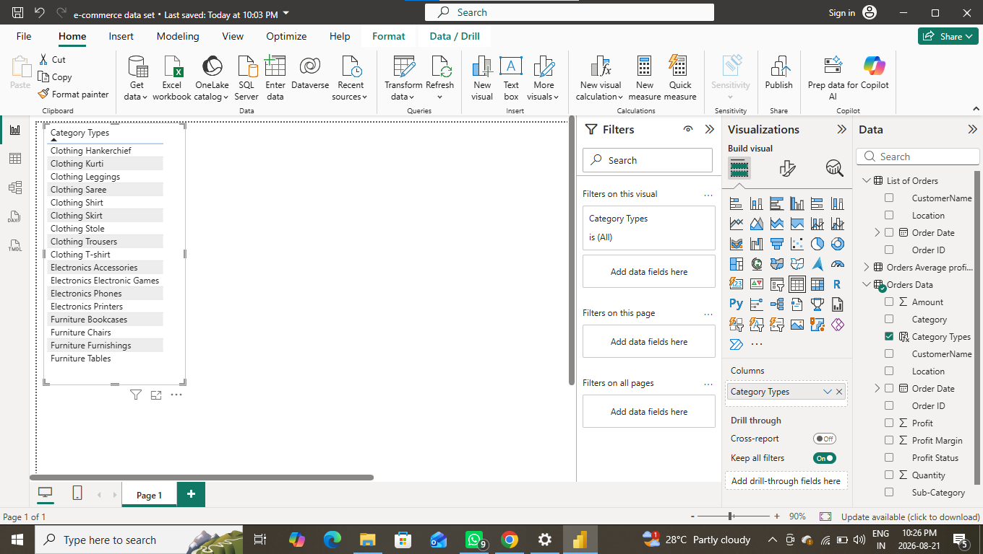

● Calculate Revenue per Order in Order Details Table: Create a calculated column inthe Order Details table to compute the revenue (Amount * Quantity) per order.
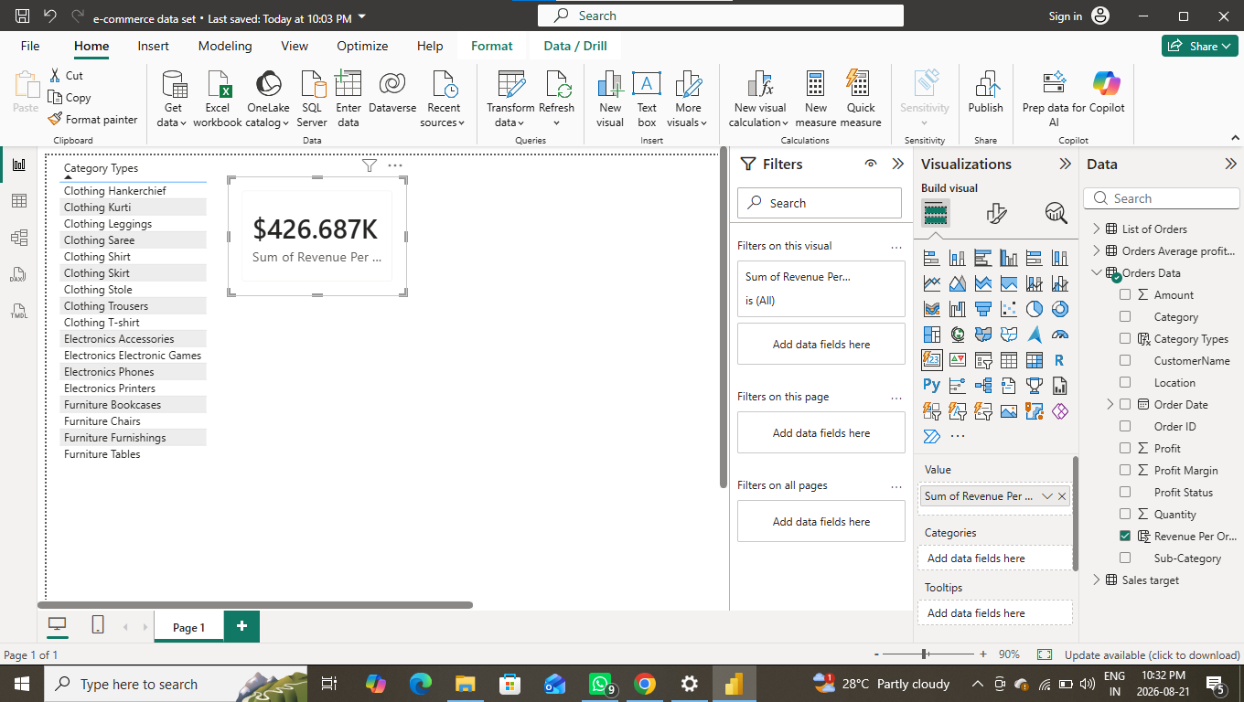

● Create a Calculated Column to Categorize Sales: Add a calculated column named
‘Sales Category’ in the Order Details table that categorizes each order as 'Above
Average' or 'Below Average' based on the Amount value.
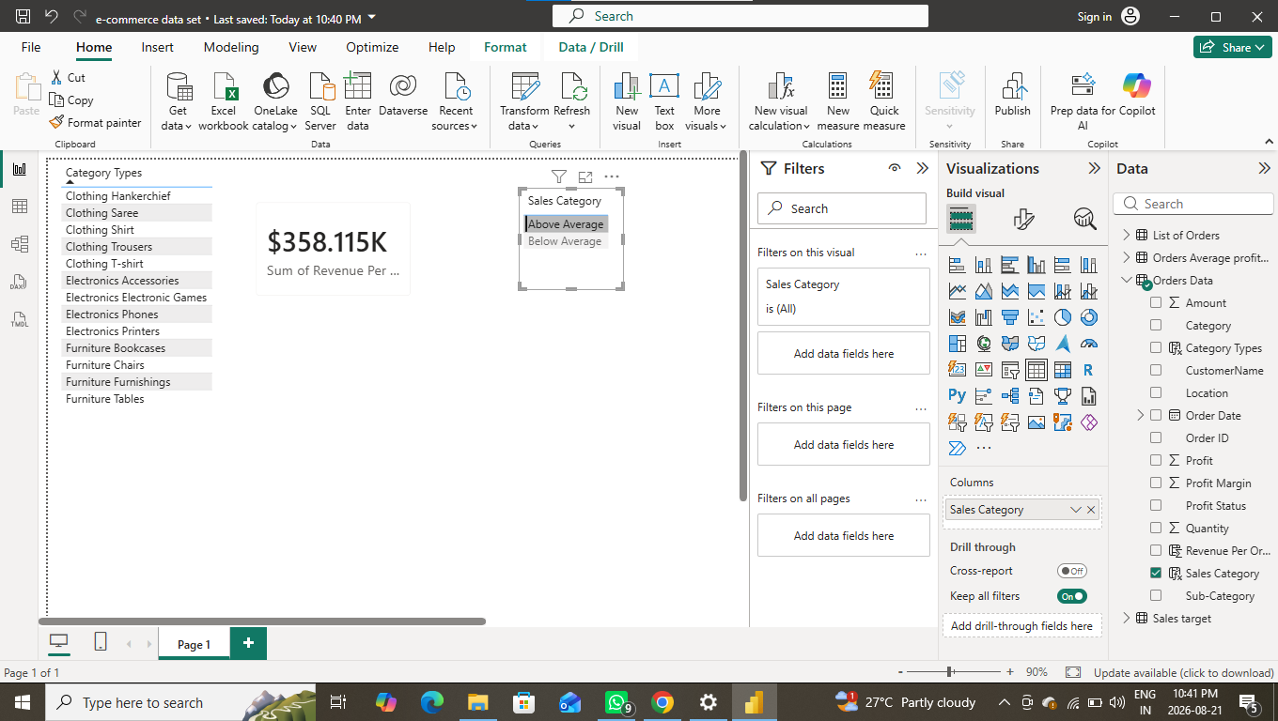

Calculated Measures
Order Count- Create a measure that calculates the total number of orders in the Order
Details table.
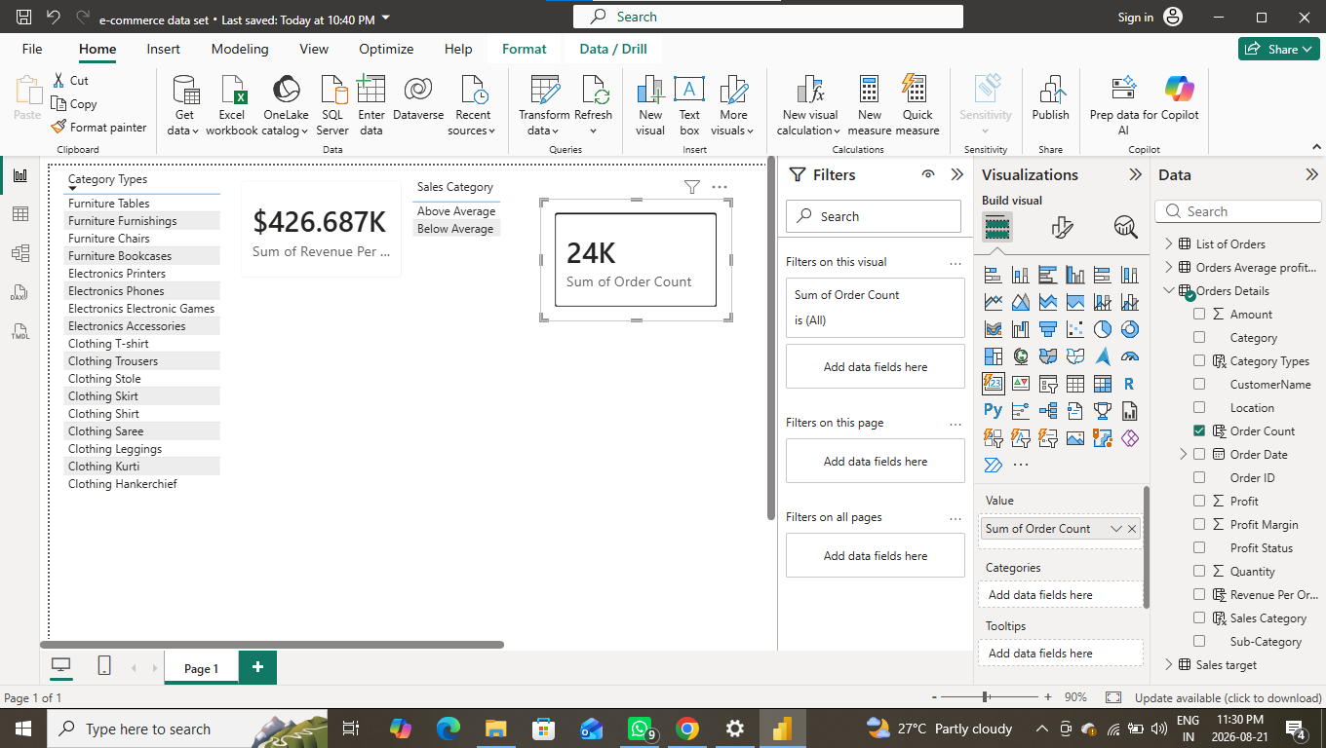

Average Profit in Delhi- Create a measure that calculates the average profit for orders
placed in Delhi.
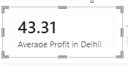

3. Year-to-Date (YTD) Sales- Create a measure that calculates total sales accumulated from the
beginning of the year up to the current order date.
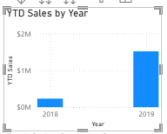

Data Visualization
● Sales Target Achievement by Category: Compare actual sales with sales
targets by category using a clustered column chart.

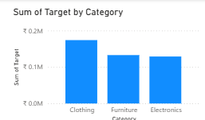
● Max Profit Margin by Sub-Category: Analyze the maximum profit margin for each sub-category of products using a donut chart.

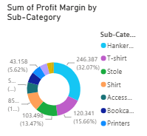
● Monthly Sales Trend: Show the trend of monthly sales over time using a linechart.
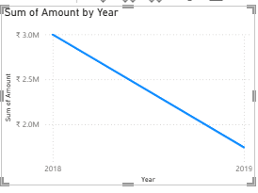

● Comparison of Profit and Quantity by Sub-Category: Compare the relationship between profit and quantity sold for different sub-categories using a scatter chart.
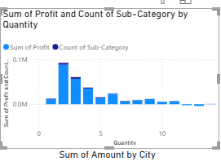
● Comparison of Total Sales Amount and Target: Create cards to succinctly display the total sales amount alongside the sales target for quick comparison and analysis. Also, create a multi-row card to display the minimum target for each segment.

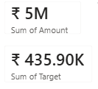

● Sales Performance Matrix: Build a matrix view to analyze how actual sales compare to sales targets across different categories and months.
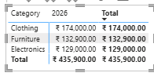
● Geographic Sales Analysis: Visualize total sales on a map by city to identify regional sales patterns.
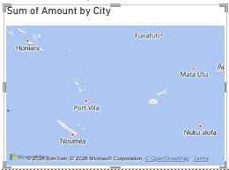

● Sales Distribution by Sub-Category: Represent the sales distribution across Different using a tree map.
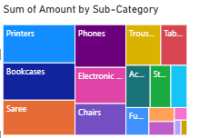

● Order Count Analysis by State: Create a funnel chart to visualize the distribution of order counts across different states.

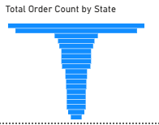

Final Output Result

